

2020

Artificial intelligence

**Name:** Mostafa Abdallah Mostafa Mansour  
**Group:** 7

**Section:** 42  
**BN: 23  
Seat number:** 924

**Github:**

**Application brief:**

**A Website on Artificial intelligence (AI) and some applications that help disabled people.**

**Screenshots:**

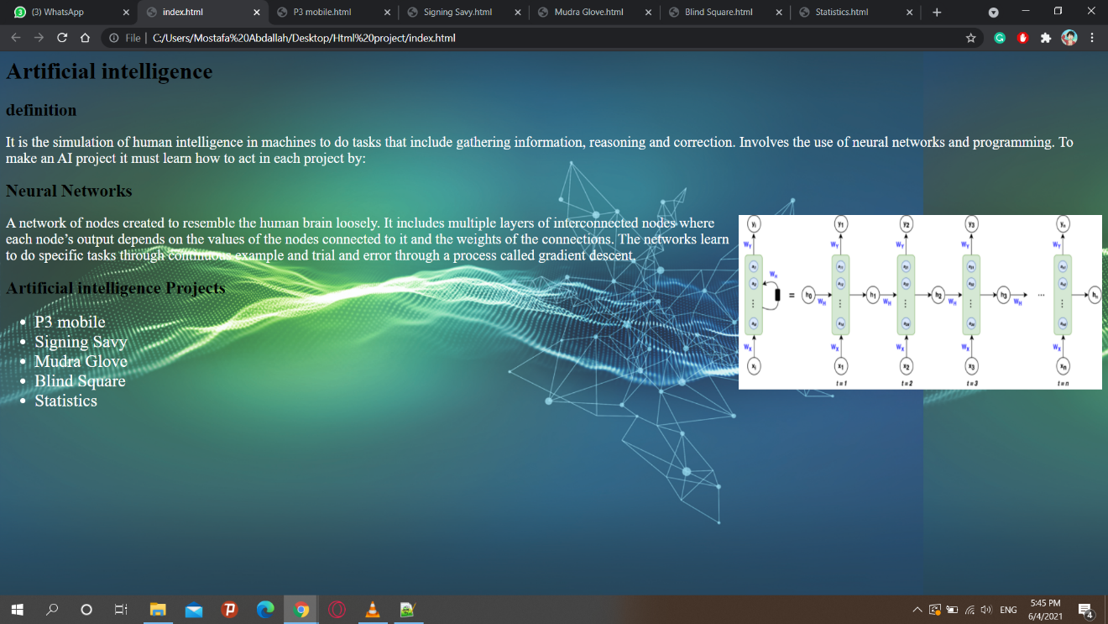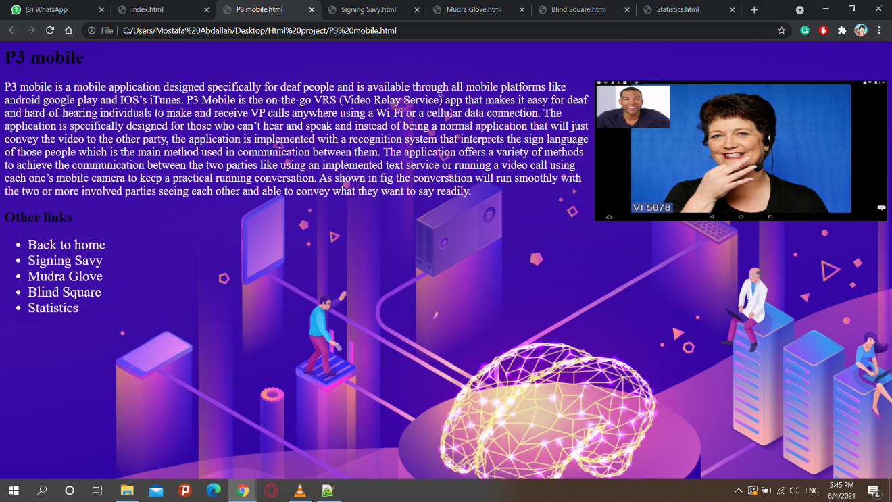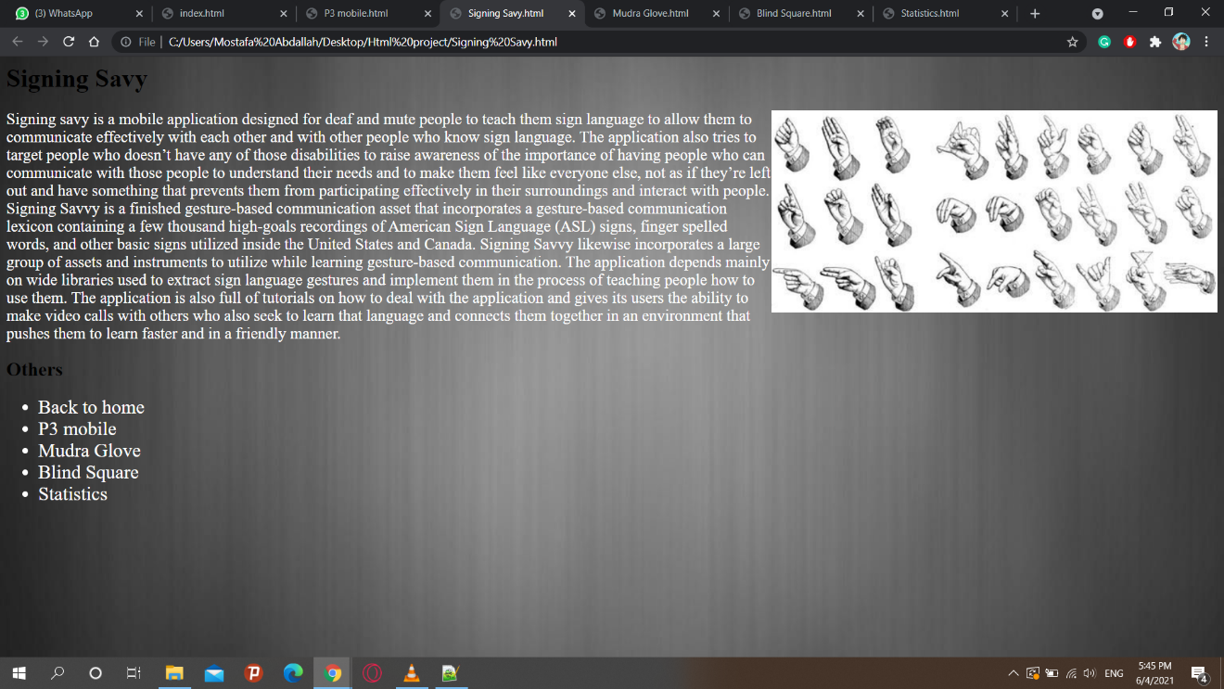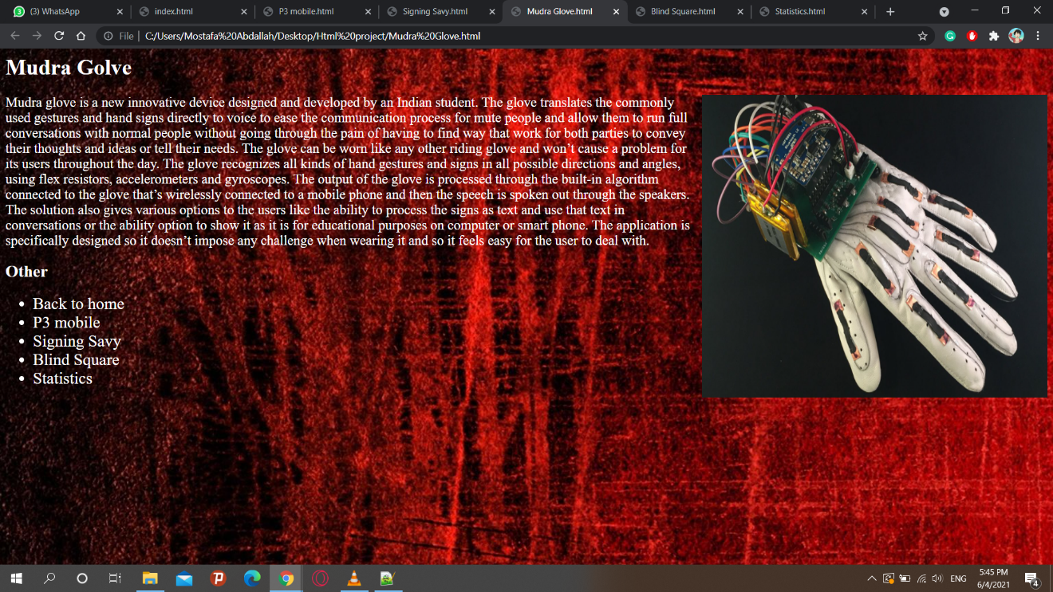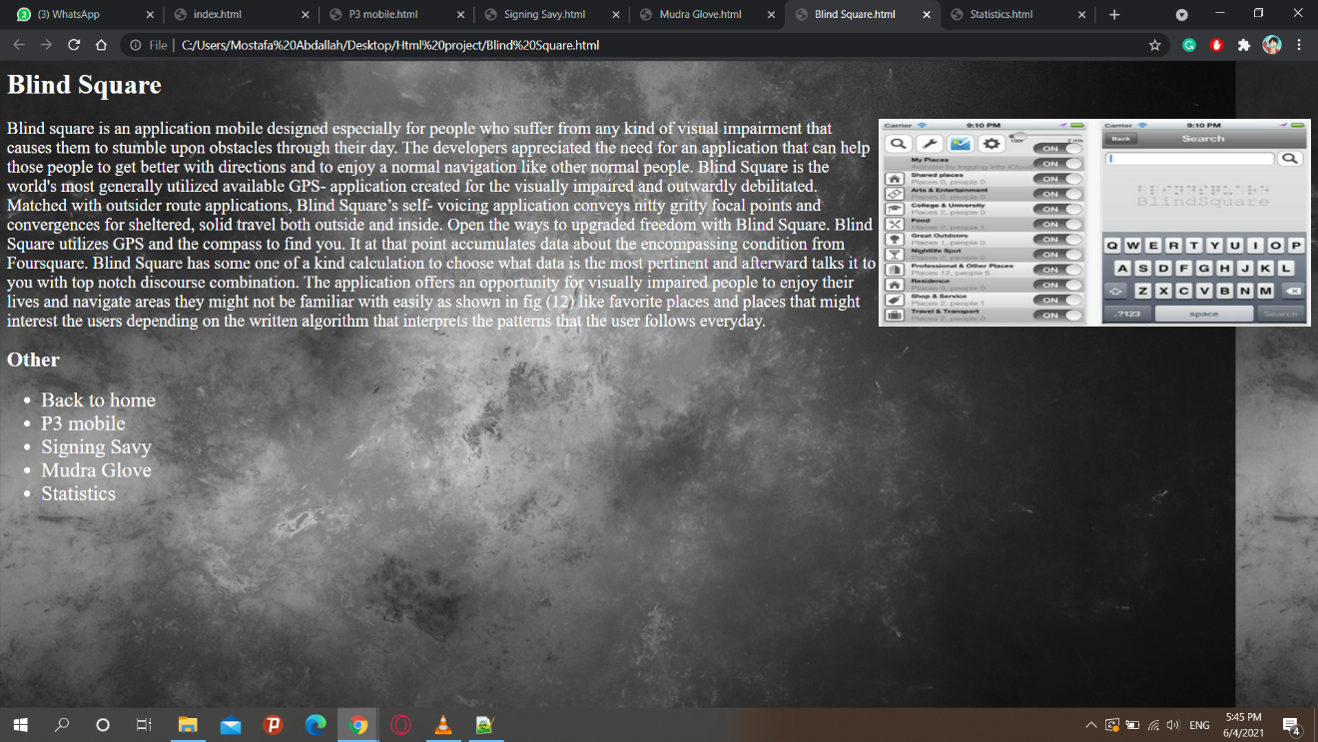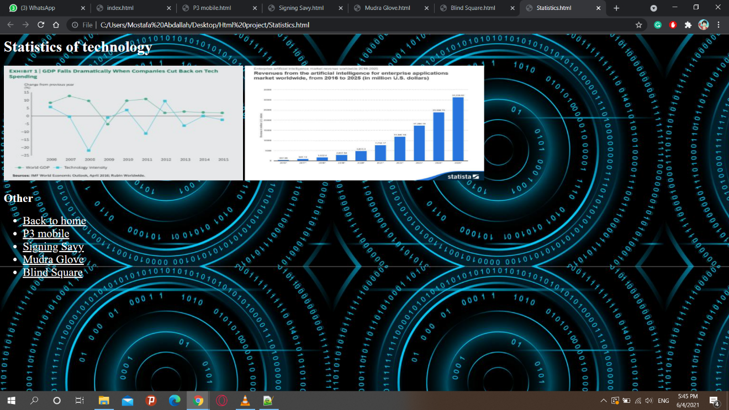

**Source code:**

